**Q20. Employee Salaries**

Write a query that prints a list of employee names (i.e.: the name attribute) for employees in Employee having a salary greater than **$2000** per month who have been employees for less than **10** months. Sort your result by ascending employee_id.

The Employee table containing employee data for a company is described as follows:

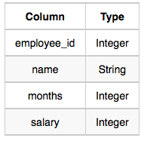

where employee_id is an employee's ID number, name is their name, months is the total number of months they've been working for the company, and salary is their monthly salary.

**Sample Input**

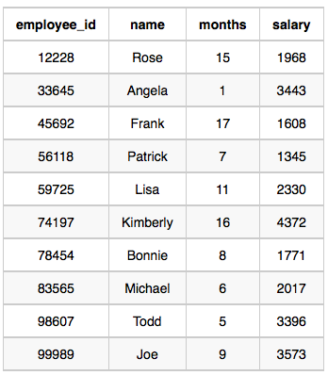

**Sample Output**

Angela

Michael

Todd

Joe

**Explanation**

Angela has been an employee for **1** month and earns **$3343** per month.

Michael has been an employee for **6** months and earns **$2017** per month.

Todd has been an employee for **5** months and earns **$3396** per month.

Joe has been an employee for **9** months and earns **$3573** per month.

We order our output by ascending **employee_id**.

**Ans**.

SELECT NAME

FROM EMPLOYEE

WHERE SALARY > 2000 AND MONTHS < 10

ORDER BY EMPLOYEE_ID